Spectral coherence: GBPUSD and USDCAD
Method 21 / daily log returns / Welch magnitude-squared coherence / Alpari D1 full available history

Study setup
Logical pair: GBPUSD , USDCAD
Broker symbols: GBPUSD_i , USDCAD_i
Snapshot: 2026-11-03_majors_alpari_D1
Timeframe: D1
Matched return window: 1999-01-05 to 2026-11-02 (UTC bar dates)
Matched return count n: 7205
Dropped unfinished last bar dated 2026-11-03 UTC after a tick-volume check against the prior complete day.
Welch: fs=1.0, nperseg=256, noverlap=128, window=hann, detrend=constant
Headline: gamma^2 nearest f=1/5; also 1/21 and 1/63
Complete matched rows (Excel): GBPUSD-USDCAD_Spectral_D1.xlsx
Complete matched rows (HTML table): GBPUSD-USDCAD_Spectral_D1_data.html

Method carried forward
Magnitude-squared spectral coherence gamma^2(f) measures shared linear power between matched daily log returns of close, ln(close_t / close_t-1), at each frequency f (cycles per day). Quotes are not inverted. Welch settings are frozen: fs=1, nperseg=256, noverlap=128, window=hann, detrend=constant. Headline is gamma^2 at the frequency bin nearest f=1/5 (five-day cycle from the formula sheet). Also reported: gamma^2 nearest f=1/21 and f=1/63, mean gamma^2 over the frequency grid, and phase of the cross-spectrum at the 1/5 bin. Coherence is unsigned (0 to 1); phase carries timing. Same-sample Pearson r is a side check only. This is not causation and not a trading signal.

Results (headline)
gamma^2 near 1/5: 0.221322
bin f (1/5): 0.199219
phase at 1/5 (rad): -2.954995
gamma^2 near 1/21: 0.201167
gamma^2 near 1/63: 0.257345
mean gamma^2: 0.237189
Pearson r: -0.456462

Target-frequency summary
period | target_f | f_bin | gamma2 | phase_rad
5 | 0.2 | 0.19921875 | 0.22132185 | -2.9549947
21 | 0.04761905 | 0.046875 | 0.20116747 | -2.8089522
63 | 0.01587302 | 0.015625 | 0.25734509 | -2.8374178

Conclusion
Headline gamma^2 near f=1/5 for GBPUSD and USDCAD: 0.2213 (bin f=0.199219, phase=-2.9550 rad). At ~1/21: 0.2012; at ~1/63: 0.2573. Mean gamma^2 = 0.2372. Pearson r = -0.4565. This is frequency-domain linkage, not a trading signal.

Charts
Daily closes

Daily log returns

Spectral coherence gamma^2(f)
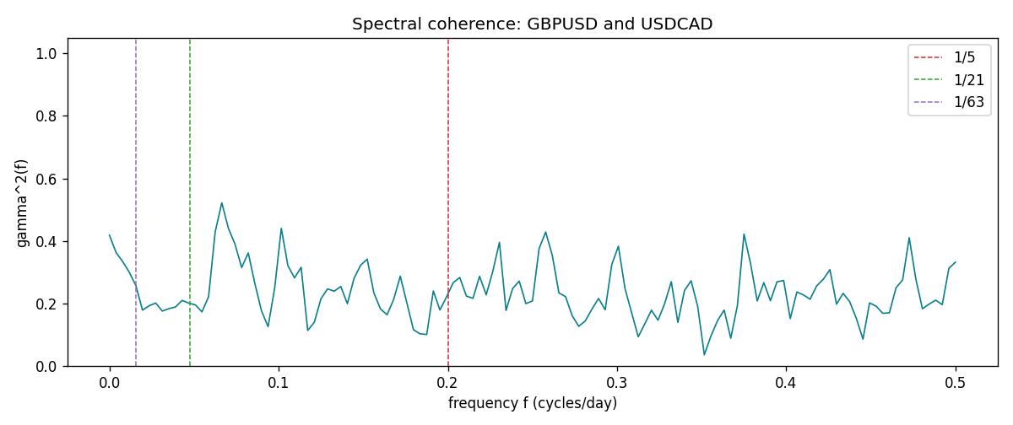

Data report
Matched rows and the coherence sheet are in the sibling Excel workbook named GBPUSD-USDCAD_Spectral_D1.xlsx. Embedding all rows as a Word table is impractical; this file holds column summaries and the first and last 15 matched rows.
Columns: time, GBPUSD_open, USDCAD_open, GBPUSD_high, USDCAD_high, GBPUSD_low, USDCAD_low, GBPUSD_close, USDCAD_close, GBPUSD_tick_volume, USDCAD_tick_volume, GBPUSD_spread, USDCAD_spread, GBPUSD_real_volume, USDCAD_real_volume, GBPUSD_log_return, USDCAD_log_return
Column summaries (matched calculation rows)
column | count | mean | std | min | 25% | 50% | 75% | max
GBPUSD_open | 7205 | 1.5161639 | 0.2182756 | 1.06854 | 1.32505 | 1.51142 | 1.63205 | 2.1066
USDCAD_open | 7205 | 1.2670469 | 0.16900802 | 0.9168 | 1.119 | 1.29857 | 1.3723 | 1.6183
GBPUSD_high | 7205 | 1.5224596 | 0.21884187 | 1.08366 | 1.32981 | 1.5182 | 1.6384 | 2.1161
USDCAD_high | 7205 | 1.2719479 | 0.16896591 | 0.9336 | 1.1234 | 1.30394 | 1.3769 | 1.619
GBPUSD_low | 7205 | 1.5098441 | 0.21750249 | 1.03518 | 1.31956 | 1.50336 | 1.62444 | 2.0983
USDCAD_low | 7205 | 1.2624879 | 0.16904619 | 0.9056 | 1.1144 | 1.29361 | 1.36793 | 1.6102
GBPUSD_close | 7205 | 1.5162333 | 0.21823062 | 1.06879 | 1.3252 | 1.5114 | 1.6322 | 2.1065
USDCAD_close | 7205 | 1.2670655 | 0.16898286 | 0.916 | 1.11851 | 1.29871 | 1.37253 | 1.6137
GBPUSD_tick_volume | 7205 | 94776.836 | 153518.92 | 62 | 9986 | 52867 | 91739 | 1273370
USDCAD_tick_volume | 7205 | 80835.261 | 147176.39 | 37 | 5509 | 40849 | 71515 | 1410818
GBPUSD_spread | 7205 | 26.978348 | 19.192834 | 0 | 11 | 20 | 50 | 50
USDCAD_spread | 7205 | 23.508952 | 18.282466 | 0 | 9 | 17 | 40 | 60
GBPUSD_real_volume | 7205 | 3.5541156e+09 | 8.441481e+10 | 0 | 0 | 0 | 0 | 2.4038164e+12
USDCAD_real_volume | 7205 | 1.8330194e+10 | 9.6578305e+10 | 0 | 0 | 0 | 0 | 2.5751613e+12
GBPUSD_log_return | 7205 | -2.188e-05 | 0.00563988 | -0.08388241 | -0.00312535 | 3.221e-05 | 0.0031749 | 0.03112653
USDCAD_log_return | 7205 | -1.219e-05 | 0.00514402 | -0.03859748 | -0.00283601 | 4.92e-05 | 0.00272763 | 0.03436319
First 15 matched rows (selected columns)
time | GBPUSD_log_return | USDCAD_log_return
1999-01-05 | -0.0028966287 | -0.010131666
1999-01-06 | -0.00060452184 | -0.0003306769
1999-01-07 | -0.002118709 | 0.0015202092
1999-01-08 | -0.0058954193 | -0.0020495197
1999-01-11 | -0.0056851331 | -0.0035137769
1999-01-12 | 0.0022657001 | 0.0066194721
1999-01-13 | 0.0091330396 | 0.0045420214
1999-01-14 | 0.0019376331 | 0.0069376546
1999-01-15 | -0.0017558204 | -0.0056905671
1999-01-18 | 0.0012112405 | 0.00098344542
1999-01-19 | 0.0018745281 | 0.002748513
1999-01-20 | -0.0049053846 | -0.0059646885
1999-01-21 | 0.0031518998 | -0.0042823796
1999-01-22 | 0.0024781662 | 0.0025057712
1999-01-25 | 0.0012066366 | 0.00085579808
Last 15 matched rows (selected columns)
time | GBPUSD_log_return | USDCAD_log_return
2026-10-13 | 0.0036434319 | -0.0046395653
2026-10-14 | -0.0049164679 | 0.0015184751
2026-10-15 | 0.0065976411 | -0.0036101503
2026-10-16 | 0.0037592051 | -0.0034322068
2026-10-19 | -0.0017500314 | -0.0018835331
2026-10-20 | 0.0055923442 | -0.0037066008
2026-10-21 | 0.0012476328 | -0.00084691787
2026-10-22 | 0.00022396082 | -0.0026307268
2026-10-23 | -0.0021146949 | 2.85545e-05
2026-10-26 | -0.0024340661 | 5.7106554e-05
2026-10-27 | -0.0023648393 | 0.0025379458
2026-10-28 | 0.0015771808 | -0.0038379274
2026-10-29 | 0.0035881935 | -0.00011436495
2026-10-30 | 0.0013450605 | -0.0010298736
2026-11-02 | 0.0010971256 | 0.00061519094
First 15 frequency bins
f | gamma2 | phase_rad | period_days
0 | 0.41856078 | 3.1415927 | inf
0.00390625 | 0.36344828 | -3.0226817 | 256
0.0078125 | 0.33419387 | -2.7582337 | 128
0.01171875 | 0.30019941 | -2.7477249 | 85.333333
0.015625 | 0.25734509 | -2.8374178 | 64
0.01953125 | 0.17884559 | -2.5424198 | 51.2
0.0234375 | 0.19274395 | -2.8004434 | 42.666667
0.02734375 | 0.20152683 | -3.0460163 | 36.571429
0.03125 | 0.17591856 | -2.857148 | 32
0.03515625 | 0.18345519 | -2.5629828 | 28.444444
0.0390625 | 0.18905808 | -3.0071243 | 25.6
0.04296875 | 0.20989951 | -3.0720226 | 23.272727
0.046875 | 0.20116747 | -2.8089522 | 21.333333
0.05078125 | 0.19560799 | -2.5757481 | 19.692308
0.0546875 | 0.17324951 | -2.9415127 | 18.285714

